}|SPECIFICATION OF FURNITURE , DOORS AND WINDOWS
ITEM | PICTURE
Pupitres (Refer to provided drawings) | Refer to drawings
Doors | Refer to drawings
windows | Refer to drawings
Teacher Tables: Metal structured table with book holder, 1200x600x750mm, made of 32mm diameter tubes, 1.5mm sheet, and 30mm thick umusave,with fast dry painting and gloss varnish | 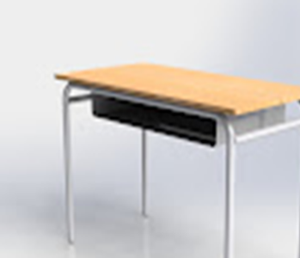  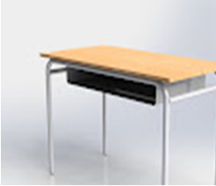
WOODEN STRUCTURED CHAIRS FOR TEACHERS made in well seasonned Nile Tulip (Umusave) or Cypress and well dried. Total height: 94 cm Seat height 45 cm Seat length: 48 cm Seat width: 44 cm. Sample to be approved by Client. All chair should be stable ,well assembled, well finished and well vernished at least 3 coats . More details are found on drawings. The sample to be approved by the client. | 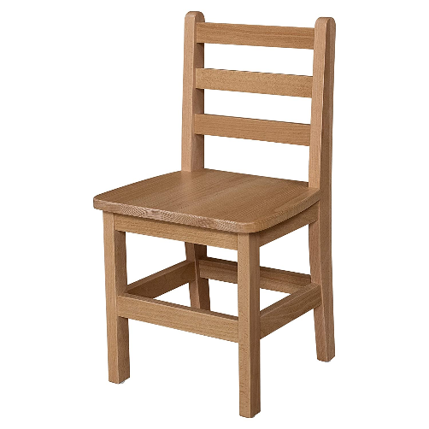
TOTAL

